St. Brigid and St. John Catholic Church 2024
Sunday | Monday | Tuesday | Wednesday | Thursday | Friday | Saturday
 | 9:00 Mass cancelled 1  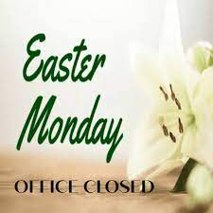 | 2 | Young at Heart 3  11:00 St. Brigid Room  Potluck/bring a dish  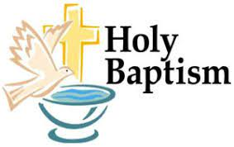  @ St. John | 4  Sisters In Christ/ St. John  Noon and 6:30 p.m. | 5 | 6  @ St. John
7  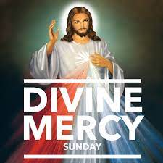 | The Annunciation 8  Of the Lord  St. Brigid Budget/Finance Meeting 5:00 p.m. | 9 | 10 | 11 | 12 | 13
Donut Sunday 14  after 9:00 Mass @ St. Brigid  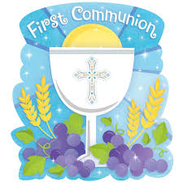  11:00 Mass @ St. John | 15  St. Vincent De Paul Meeting 5:30 St. Brigid Room/CCC | 16 | 17  St. John Parish Council after 6:30 p.m.Mass | 18  St. Brigid Parish Council 7:00 p.m | 19  St. Brigid, CCC 9-2 | 20
21 | 22 | 23 | 24 | 25 | 26 | 27
Last day RE at St. John 28  St. Brigid Religious Ed  CCC 10-11:30 | 29 | 30 |  |  |  | OVER
*See the bulletin for more information about these events * Follow the St. Brigid and St. John Church pages on Facebook * Visit the parish website at http://www.stbrigidvg.org
** If you have information you would like to add to the monthly calendar, please submit to the Parish office by the 20th of the prior month. brigidvg@bbtel.com

April 14 - Sacrament of First Holy Communion @ 11:00 a.m. Mass.
Please keep our first communion candidates, in prayer as they approach their special day on April 14th. Owen Taylor, Mason Duvall, Josie Lambert, Zaxlie Fackler, Zane Hardesty During this time of preparation it is important that they feel the love and support of their church family so we are asking for volunteers to drop a note of encouragement or congratulations in the mail to them. Located in the back of church you will find their pictures along with some small slips of with their name and address for you to take. Thank you so much for all your prayers, love, and support of our wonderful candidates as they grow in our Catholic faith.

April 28 – Last Day of RE at St. John

April 28, 10-11:30 St. Brigid CCC – End of year Celebration for RE Students, teachers, and families! Join us for food, fun and fellowship!

