St. Brigid and St. John Catholic Church 2023
Sunday | Monday | Tuesday | Wednesday | Thursday | Friday | Saturday
 |  |  |  | 1  St. John Sisters In Christ Noon and 6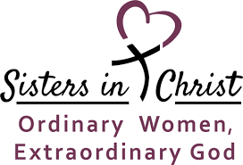 | 2 | 3  Winona Skees’ 90th birthday party! 2-5 p.m. at St. John
4  Most Holy Trinity  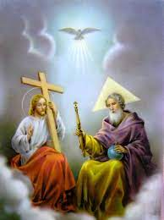 | Backyard Catholic 5  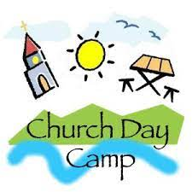  K-5 @ St. John  9 am-5 pm | 6  Father Jeff-St. Meinrad  Return 6/16/23  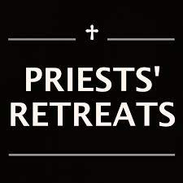 | 7  11:00 CCC, Bring a Dish  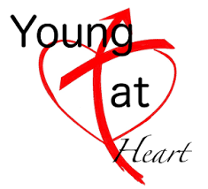 | 8 | 9 | 10
Donuts after Mass 11  Corpus Christi Sunday  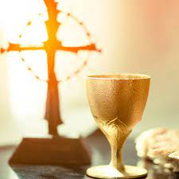 | 12 | 13 | 14 | 15 | Blood Drive 16  CCC - 9am-2pm  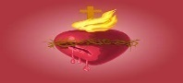  Feast of The Most Sacred Heart of Jesus | 17
18 | 19 | 20 | 21  St. John Parish Council after 6:30 Mass | 22  St. Brigid Parish Council 7:00 p.m. | 23 Happy 1 year to Father Jeff | 24
25  Raffle Drawing 1:30 p.m.  ** watch bulletin for more info | 26 | 27 | 28 | 29 | 30 | OVER
*See the bulletin for more information about these events * Follow the St. Brigid Church page on Facebook * Visit the parish website at http://www.stbrigidvg.org
** If you have information you would like to add to the monthly calendar, please submit to the Parish office by the 20th of the prior month. brigidvg@bbtel.com

June 4 The Most Holy Trinity
Trinity Sunday is a Christian festival widely celebrated by Western Churches. It falls on the first Sunday after Pentecost, which is the 50th day after Easter. Trinity Sunday, in its essence, celebrates the mystery of faith and unity on and of the Holy Trinity. There is one God, who is Father, Son and Holy Spirit. The Trinity, or Holy Trinity, is a way of describing God the Father, God the Son and God the Holy Spirit.
Jesus approached and said to the disciples “Go, therefore, and make disciples of all nations, baptizing them in the name of the Father, and of the Son, and of the Holy Spirit. Matthew 28:19.
June 11 Corpus Christi
What is Corpus Christi in a Catholic church?
The name 'Corpus Christi' is Latin for 'the body of Christ'. This jubilant festival is celebrated by Roman Catholics and other Christians to proclaim the truth of the transubstantiation of bread and wine into the actual body of Christ during Mass.

June 16 The Most Sacred Heart of Jesus Celebrated on the third Friday after Pentecost, the devotion to the Sacred Heart of Jesus recognizes Jesus' great love for us as symbolized by His heart. How fitting that we have a Blood Drive scheduled on This Feast Day

June 24 The Nativity of St. John the Baptist Each year on June 24 the Catholic Church honors the birth of John by reflecting on his unique role as the precursor of Jesus. The solemnity held on that date praises John as a worthy example of what it means to be a follower of Christ. A solemnity is the most significant feast the Church can establish.

