St. Brigid and St. John Catholic Church 2023 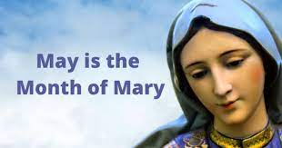
Sunday | Monday | Tuesday | Wednesday | Thursday | Friday | Saturday
 | 1 | 2 | 3  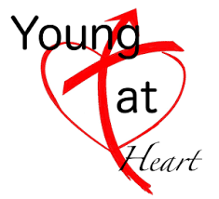  11:00 CCC, Bring a Dish  Mtg. after 6:30 Mass for Backyard Catholic | 4  St. John Sisters in Christ Noon and 6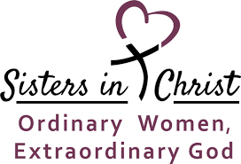 | 5 | 6
7  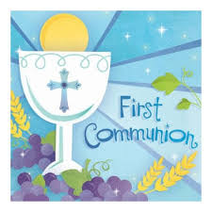9:30 Mass/St. Brigid | 8 | 9 | 10  Confirmation Practice @ St. John 7:00 p.m. | 11 | 12 | 13  6:30 Mass @ St. John  Reception to follow
14 | 15  Safe Environment Training, St. James, 6:30 p.m. | 16 | 17  St. John Parish Council after 6:30 Mass | 18  St. Brigid Parish Council 7:00 p.m. | 19 | 20
21  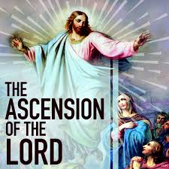  RE End of Year Party at St. Brigid | 22 | 23 | 24 | 25 | 26 | 27
28  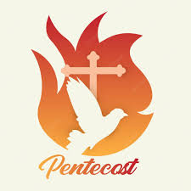 | 29  Office Closed | 30 | 31  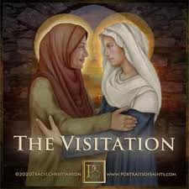 |  |  | OVER
*See the bulletin for more information about these events * Follow the St. Brigid Church and St. John the Baptist pages on Facebook * Visit St. Brigid parish website at http://www.stbrigidvg.org ** If you have information you would like to add to the monthly calendar, please submit to the Parish office by the 20th of the prior month. brigidvg@bbtel.com
Pickle Ball – Thursdays @ 1:30 in St. Brigid CCC – All are Welcome.
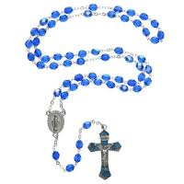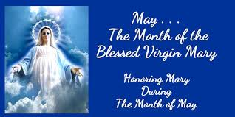
Why is May the Month of Mary? The tradition of dedicating the month of May to Mary, came about in the 13th century. Some say because it was created to replace various pagan cults. The actual reason is the fact that this month is the time when spring is at the height of its beauty.

“I feel so happy to be able to help the children who beg me for protection. But so many do not ever come to me.” —Our Lady of the Miraculous Medal

Confirmation -May 13 @ 6:30 p.m. 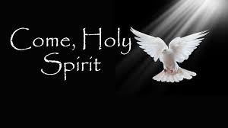
Pentecost Sunday – May 28.
In the New Testament, Pentecost was the occasion of the descent of the Holy Spirit upon the Apostles and other followers of Jesus Christ, as described in the Acts of the Apostles 2:1–31. Did you know that the feast of Pentecost is often referred to as the birthday of the Church? It is called that because Pentecost is when the apostles went out among the people and began spreading Jesus' message, thus establishing the beginning of the Church.

