St. Brigid and St. John the Baptist Catholic Church 2022
Sunday | Monday | Tuesday | Wednesday | Thursday | Friday | Saturday
Small Christian Communities (SCC) to meet after Mass thru November 13th.^{h}  ^{Church Basement/Classroom} |  | Holy Day 1  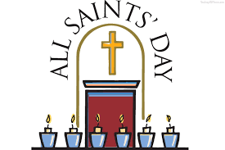  Communion Service:  9:00 a.m. St. John  5:30 p.m. St. Brigid  SCC 9:00 CCC | 2  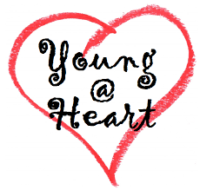  11 a.m., Bring a side dish! Join us!  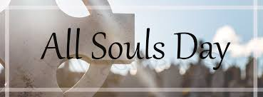 | 3  St. John  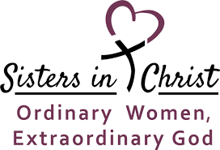  Noon and 6:30 p.m. | 4  Father Jeff Returns | 5
RE @ St. Brigid 6  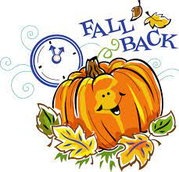 | 7  St. Brigid  Finance Meeting  6:00 p.m. | 8  Small Christian Community (SCC) 9:00- St. Brigid Room/ CCC | 9 | 10 | 11 | 12  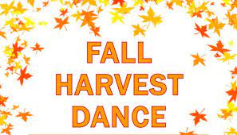  St. John 7:30 – 12  St. John’s  Confirmation Class Little Holy Land Tour
Donuts After 9:30 mass 13  Heibert Baptism  Cemetery Service  St.John-after 11:30 Mass  St. Brigid – 4:00 p.m. | 14 | 15  SCC 9:00- St. Brigid Room/ CCC | First 16  Reconciliation  St. John 6:00 p.m.  Parish Council after 6:30 Mass, St. John | 17  St. Brigid Parish Council 7:00 p.m. | 18 | 19
RE @ St. Brigid 20  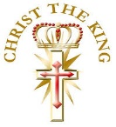 | 21 | 22 | 23 | 24  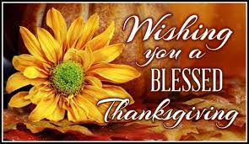 | 25  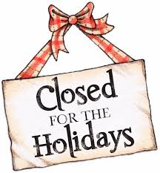 | 26
27  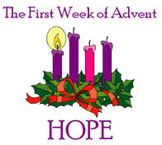 | 28 | 29 | 30 |  |  | FLIP  OVER

November 1 – All Saints Day : Holy Day of Obligation: All Saints' Day is a solemn holy day of the Catholic Church celebrated annually on November 1. The day is dedicated to the saints of the Church, that is, all those who have attained heaven. It should not be confused with All Souls' Day, which is observed on November 2, and is dedicated to those who have died and not yet reached heaven.
November 2 – All Souls Day: All Souls' Day, in Roman Catholicism, a day for commemoration of all the faithful departed, those baptized Christians who are believed to be in purgatory because they died with the guilt of lesser sins on their souls.
November 20 – Our Lord Jesus Christ, King of the Universe - On the last Sunday of each liturgical year, the Church celebrates the Solemnity of Our Lord Jesus Christ, King of the Universe, or Christ the King. Pope Pius XI instituted this feast in 1925 with his encyclical Quas primas (“In the first”) to respond to growing secularism and atheism. He recognized that attempting to “thrust Jesus Christ and his holy law” out of public life would result in continuing discord among people and nations. This solemnity reminds us that while governments come and go, Christ reigns as King forever.
November 27, The First Sunday of Advent symbolizes HOPE. The First Sunday represents Isaiah and other prophets of the Bible that predicted the coming of Jesus. Also, For Catholics, the new Liturgical Year commences with the first Sunday of Advent. In this new Liturgical Year, the Church not only wishes to indicate the beginning of a period, but the beginning of a renewed commitment to the faith by all those who follow Christ, the Lord. This time of prayer and path of penance that is so powerful, rich and intense, endeavors to give us a renewed impetus to truly welcome the message of the One who was incarnated for us. In fact, the entire Liturgy of the Advent season, will spur us to an awakening in our Christian life and will put us in a ‘vigilant’ disposition, to wait for Our Lord Jesus who is coming:
‘Awaken! Remember that God comes! Not yesterday, not tomorrow, but today, now! The one true God, "the God of Abraham, Isaac and Jacob," is not a God who is there in Heaven, unconcerned with us and our history, but he is the-God-who-comes.’¹

