St. Brigid and St. John Catholic Church 2022
Sunday | Monday | Tuesday | Wednesday | Thursday | Friday | Saturday
 |  |  | 11 am CCC, St. Brigid 1  Bring A Side Dish  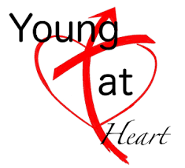 | 2  Noon and 6:30 p.m. potluck/ St. John | 3  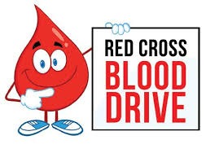  CCC 10-2 | 4
5  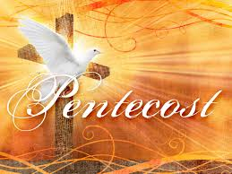 | St. John K-6th 6  Bible School 9am-5pm  Fr. Dan leaving for Priest Assembly at St. Meinrad | 7 | 8 | 9  Father Dan returns from Priest Assembly | 10 | 11
Coffee and Donut 12  after 9:30 mass. St. Brigid  Father Dan Retirement Potluck/St. John after 11:30 mass | 13 | 14 | 15 | 16  St. Brigid Parish Council 7:00 p.m. | 17 | 18
Happy Father’s Day 19  Father Dan’s Last Mass  Retirement Potluck/St. Brigid CCC 2-4 p.m.  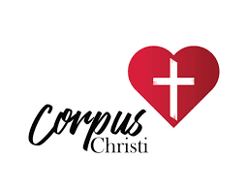 | 20 | 21 | 22  Father Dan’s Last Day  We Will Miss You! | 23  Father Jeff Gatlin  The Nativity of St. John the Baptist | 24  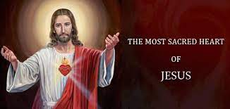 | 25  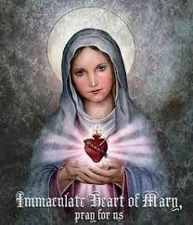
26 | 27 | 28 | 29 | 30
*See the bulletin for more information about these events * Follow St. Brigid & St. John on Facebook * Visit the parish website at http://www.stbrigidvg.org/
Pickle Ball, Thursdays at 1:30 p.m. CCC, St. Brigid. All are welcome!!

