SECOND SUNDAY OF EASTER
St. Brigid of Ireland April 12, 2026 St. John the Baptist Catholic Church Catholic Church

E 4
Pastor:
Fr. Jeff Gatlin
Rectory:
270-877-2546
Deacon:
Mike Ryan
Office:
270-272-6789

ANOINTING OF THE SICK:
Notify the parish office when a family member is hospitalized.
BAPTISM: Contact the parish office for information about the required preparation class.

BULLETIN: Submit information in writing by note or email to the parish office no later than 4:00 p.m. on Wednesday for the following weekend. When sending an email, please put “BULLETIN” in the subject line along with the name of the parish it pertains to.

MARRIAGE: Contact Father Jeff or Deacon Mike at least 6 months prior to the wedding date to complete required marriage preparations and to schedule the date.
OCIA (Order of Christian Initiation of Adults): Contact Deacon Mike Ryan (270) 877-0546 or (270) 272-6789
Contact the DEW MEMORIAL LIBRARY:
(St. Brigid Church basement):
Open: Sunday after 9:00 a.m. Mass & 45 minutes before all other Masses.

314 E. Main Street 657 St. John Church Rd.
Vine Grove, KY 40175 Elizabethtown, KY 42701
Clustered Parish Office: Clustered Parish Office:
(270) 877-2461 (270) 877-2461
Email: brigidvg@bbtel.com
Website: www.stbrigidvg.org Dir. of R. Education:
Hillary Henderson (270) 402-7461 stjohndre1@gmail.com
Pastoral Associate
MASS SCHEDULE:
Saturday (Vigil): 6:30 p.m.
Sunday: 11:00 a.m.
Tuesday: 9:00 a.m. Wednesday: 6:30 p.m.

RECONCILIATION:
Saturday before Mass from 5:00-6:00 p.m. or by appt.

PARISH COUNCIL MEMBERS:
President: Greg Thompson
Secretary: Jan Thomas

CHAIRPERSONS:
Administration: David Yates
Formation: Lisa Thomas
Parish Life: Doug Updegraff
Worship: Sarah Mattingly

Deacon Mike Ryan: (270) 877-2461
Extension 3
Youth Minister:
Lori Law: (270) 723-0157
MASS SCHEDULE:
Sunday: 9:00 a.m. & 4:00 p.m.
Monday: 9:00 a.m.
Thursday: 9:00 a.m.
RECONCILIATION:
Sunday before Mass from 2:30 -3:30 or by appt.
ROSARY: After weekday Masses
PARISH COUNCIL MEMBERS:
President: Bill Cochran
Vice-President: Angie Bragg
Secretary: Ken Baker
At-Large Members: Jane Alder
Linda Skeeters CHAIRPERSONS:
Formation: Tina Yates
Parish Life: Angie Bragg
Worship: Judy Cochran

Sat | Apr 11 | 6:30 p.m. | St. John | In honor of the living and deceased members of Emil and Anna Brangers Family,  In loving memory  of Marcella Brangers | VIGIL: SECOND  SUNDAY OF EASTER
Sun | Apr 12 | 9:00 a.m. | St. Brigid | In loving memory of  Irene Deveney,  In honor of living and deceased members of Virgil and Mary Ray Family | SECOND SUNDAY  OF EASTER
Sun | Apr 12 | 11:00 a.m. | St. John | In honor of Noelle  and Robert Joseph Keller,  For All Parishioners | SECOND SUNDAY  OF EASTER
Sun | Apr 12 | 4:00 p.m. | St. Brigid | In loving memory of Leo Padgett,  Our Parish Family | SECOND SUNDAY  OF EASTER
Mon | Apr 13 | 9:00 a.m. | St. Brigid | Our Parish Family | Easter Weekday
Tues | Apr 14 | 9:00 a.m. | St. John | In loving memory of  Barbara Taylor | Easter Weekday
Wed | Apr 15 | 6:30 p.m. | St. John | In loving memory of  Barbara Taylor | Easter Weekday
Thurs | Apr 16 | 9:00 a.m. | St. Brigid | In loving memory of James Randall Copley | Easter Weekday
Sat | Apr 18 | 6:30 p.m. | St. John | In honor of the living and  deceased members from the Nall and Taylor Families,  For All Parishioners | VIGIL: THIRD  SUNDAY OF EASTER
Sun | Apr 19 | 9:00 a.m. | St. Brigid | In loving memory of members from Lary Dale Fackler Family,  In loving memory of  Elizabeth Wiseman | THIRD SUNDAY  OF EASTER
Sun | Apr 19 | 11:00 a.m. | St. John | In loving memory of  Clarence Jenkins,  In honor of Dennis Parrett | THIRD SUNDAY  OF EASTER
Sun | Apr 19 | 4:00 p.m. | St. Brigid | Our Parish Family | THIRD SUNDAY  OF EASTER

St. John and St. Brigid Prayer List

To add someone to the prayer list, please call the parish office at (270) 877-2461.
Sam Adams, April Allen, Dennis Arnold, Lucy Arnold, Joe Ash, Shannon Barnes, Denise Barnett, Keith Baughman, Timothy Birch, Leon Blair, Teresa Blaycock, Charlie Bowers, Everett Brown, Jason Brown, Joseph Bryant. Richard Bryson, Carol Buchanan, Joe Buchanan, Linda Buchanan, Jeremy & Margie Buyer, Greg Byerly, Glenn Canaday, Nancy Carman, Steve Carver, Sue Caswell, Emmett Cecil, Jr. Bobby Chism, James Chism, Betty Jo Cooper, Rose M. Cooper, Denise Corbett, Heidi Correa, Teresa (Terry) Cowley, Jeff Craig, Michael Dalton, Jerry Deom, Judy Deom, Tommy Deom, Roan Dowell, Pastor Charlie “Pete” Elliott, Danny Embry, Julie Fagan, Delphine French, Wayne Garcia, Dayle Gilliatt, Danny Greenwell, Carrie Gribben, Jackie Hall, Joe Pat Hall, Lamar Hardesty, N. J. Hardesty, Jimmy Harper, Cheryl Hart, David and Denette Hebert, Eileen Heinen, Susan Horton, Frank Inanely, Braddock Inman, Eve Jarboe, Pasita Javier, Paul Jenkins, Betty Lou Jones, Bob Jones, Mark Kennedy, Violet Knoop, Robert Krauser, Mary Colleen Learned, Richard Lee, Jenny Leonhardt, Denzil Lile, Jackie Long, Lori Love, Mary Sue Marski, Shelly Martin, Martina Masoni, Ron Masoni, Kay Matheney, Don Mattingly, Paul Michael Mattingly, Kay McGuire, Angela Miles, Tate Miller, Starla Miller, Brixten Muir, Alexandra Munn, David Murray, Brenda Niles, Aira & Zairah Nixon, Elaine Ray Ogletree, Maggie Olson, Theresa Owens, Bill Padgett, Jim Padgett, Joe Padgett, Johnny Padgett, Dennis and Lisa Parrett family, Bill Pawley, Annie Pierce, Wendy Pike, Adrianna Porter, Jeremy Porter, Mary Ray Portwood, Ernie and Linda Pyzocha, Adrian Ray, Jimmy Ray, Mary Agnes Ray, Rob Redmond, Theresa Riney, Joel Rivera, Betty Robbins, Alaina Rogers, Les Rogers, Margaret Ryan, Pat and Mary Ryan, Russ Salvia, Margit Sanders, Caroline Seabee, Karen Shaffer, John Sheroan, Erica Shook, Chad Sims, Brittany Sines, Greg Skeeters, Karen Smith, Magdalena “Maggie” Smith, Sheila Smith, Ken Spangenberger, Greg Stevens, Nolan Stith, Shawn Taylor, Joe Thomas, Robert L. Thomas, Norbert Thompson, Debi Turner, Mary Ann Vance, Stacey Vance, Pauline Vessels, Stacy Vessels, Kathy Watkins, Mary Via, Elfriede Wheeler, Paul A. Whelan, Jan Wilke, Jennifer Williams, Lucas Williams, Melissa Thompson Williamson, Gail Wilson, Marie Wirth, Connor Wright, Joe Herman Yates, Tony Yates and all the sick, both mentally and physically.

To add someone to the military list, please call the parish office at (270) 877-2461.
MAJ Jordan Benton, E6 Jose Bonilla, SPC Brenna Brown, 2LT Ryan Cunningham,
CW3 Steven D. Elliott Ret, Sgt. Lance Etsitty, Sgt. Luiz Etsitty, AD3 Seth Filburn, 1Lt Matthew Fischer, 1LT Tyler Hall, MAJ Connor (Holster) Howard, 1LT Olivia Jerolaman, 1LT Paul E. Kotarski, A1C Joseph Manco, SFC Peter Novak, LTCMDR Erin Pedersen, James Rogers, Tony Rogers, Jonathon Sifford, Jeffrey Slade, CSM Vance Snider, Brian Tomassi, A1C Daniel Trombone, Ethan Unseld, SGT Evan Wilson, WO2 Evan Vaughan, SGT Clay M Wilson, SS Shelby Nicole Winchester, TSGT Jeremy Yates, and for all who serve and have served our country.

Second Sunday of Easter (April 12, 2026)

“All who believed were together and had all things in common; they would sell their property and possessions and divide them all according to each one's need.” Acts 2:44-45

The early church practiced the purest form of stewardship. Their generosity was a realization that all they had belonged to God and it was entrusted to them for the sake of others.

For Both Parishes

ATTENTION UPDATE PROCESS - St. Brigid of Ireland/St. John the Baptist Church office is planning to update the paper Parish Directory. This directory has not been updated since 2021. It will include addresses, phone numbers and email addresses but NO pictures. The book will include parishioners from both parishes. It is small and very convenient for quick needs. If you have moved, changed phone numbers or any pertinent information, please call the office at 270-877-2461 or e-mail brigidvg@bbtel.com. This project is just beginning but information needs to be gathered by April 15th so that we can begin publishing soon.

PICKLEBALL – Saint Brigid gym is open for pickleball on Mondays and Thursdays at 9:30 a.m. Come, enjoy the physical activity, and have fun at the same time.

GYM WALKING – St. Brigid gym is open M-W-F mornings from 8:00 a.m.-10:00 a.m. for anyone who would like to come walk.
ST JOHN BUNCO NIGHT - will host for both parishes on Thursday, April 23 at 6:00 p.m. Join us for a Taco Bar Supper and a fun night of bunco. All are welcome!
THE KNIGHTS OF COLUMBUS PULLED PORK DINNER - Sunday, April 26, 2026, 10:00 a.m. to 2:00 p.m. Drive through behind the K of C Hall. Menu consists of pulled pork, baked potato, baked beans, roll, soda/water bottle. Price is $12.00 per meal. POC is John Pike at 270-307-1499.
THE KNIGHTS OF COLUMBUS – Volunteers will be doing home repairs in the mountains of Appalachia for the needy and elderly on April 26th through May 2nd. Donations for building materials are needed and appreciated, Checks should be made to Vine Grove-Owensboro Inc, with home repairs on the memo line. Mail checks or donations to Chrles E. Jones, 500 Milimish Road, Vine Grove, KY 40175.

St. John The Baptist Catholic Church

Monthly Budget Amount Needed: $13,854.17
Monthly Collection for March: $15,799.03
Monthly Collection for April: $ 4,063.41

WELCOME PACKETS – If you would like to become a member, or learn more about St. John Parish, please take a Welcome Packet in the church lobby. You may return the stewardship form to Father Jeff or place it in the collection basket.

ROAD TRIP- Join us on Monday, April 20, as we travel to Passionate Nuns of St Joseph Monastery in Whitesburg, KY. We will leave St John at 9:30 am, spend time at the Monastery and then stop for lunch on the way back. Dale Givan welded the stainless-steel cross that adorns their church. You need to look on their website for the awesome picture. All are welcome to join us. For more information, contact Clarissa Yates 270-766-7821.

STEWARDSHIP WEEKENDS – Watch the Bulletin for Stewardship weekend dates – possibly April 18th-19th and April 25-26th. Please be prayerfully considering your Time Talent and Treasure to our Church.
FIRST COMMUNION/CALL TO SERVICE: Please keep our first communion candidates, Brice Churchman, James Diehl, Anna Duvall, Emrie Hatfield, Kara Meredith, Matthew Meredith, and Eleanor Yates, in prayer as they approach their special day on April 19th. During this time of preparation, it is important that they feel the love and support of their church family, so we are asking for volunteers to drop a note of encouragement or congratulations in the mail to them. Located at the back of church you will find their pictures along with some small slips of paper with their name and address for you to take. Thank you so much for all your prayers, love, and support of
our wonderful candidates as they grow in our Catholic faith.

St. John Liturgical Ministers
VIGIL: SECOND SUNDAY OF EASTER | Saturday, April 11, 2026, 6:30 p.m.
Eucharistic Ministers | Amy Thomas, Rhonda Newton,  Mary Ellen Williams
Lector | Amy Thomas
Gift Bearers | Joanna Sherrard, Jan Thomas
Greeter | Shannon Burba
Server | Oliver Henderson, Kaytie Pawley
SECOND SUNDAY OF EASTER | Sunday, April 12, 2026, 11:00 a.m.
Eucharistic Ministers | Libby Brangers, Rick Powers,  Danette Powers
Lector | Abby Wright
Gift Bearers | Gary and Libby Brangers
Greeter | Libby Brangers
Server | Mason Flowers, Jarrett Diehl
VIGIL: THIRD SUNDAY OF EASTER | Saturday, April 18, 2026, 6:30 p.m.
Eucharistic Ministers | Joanna Sherrard, Becky Thomas,  Lori Shinault
Lector | Mary Ellen Williams
Gift Bearers | Kay and Bob Jones
Greeter | Theresa Rainey
Server | Zoey Thomas, Kaytie Pawley
THIRD SUNDAY OF EASTER | Sunday, April 19, 2026, 11:00 a.m.
Eucharistic Ministers | First Communion Families
Lector | First Communion Families
Gift Bearers | First Communion Families
Greeter | First Communion Families
Server | First Communion Families

Ushers for April 2026: Saturday 6:30 p.m. Mass – Kevin Thomas, Drew Thomas
Sunday 11:00 a.m. Mass – David Pike, Nick Thomas

St. Brigid Catholic Church

Monthly Budget Amount Needed: $29,758.33
Monthly Collection for March: $39,984.15
Monthly Collection for April: $10,314.00

WELCOME PACKETS – If you are interested in joining our parish, please pick up a Welcome Packet at the church doors. Complete the registration form and either drop it in the collection basket or mail it to the office. If you just need to update your registration, there are also forms available.

FEEDING AMERICA – is April 14th from 5:00 p.m. to 7:00 p.m. It is located at the warehouse on Peterson Drive in Elizabethtown. Please come out and volunteer. Remember to wear your closed toe shoes to prevent injuries while handling canned goods.

FIRST COMMUNION – will be held on April 26, 2026, at the 9:00 a.m. Mass. Please pray for our children: Taylor Duvall, Madison Turner, Anessa Jacobs, Bristol Wood as they prepare for this blessed sacrament.

St. Brigid Liturgical Ministers

SECOND SUNDAY OF EASTER | Sunday, April 12, 2026, 9:00 a.m.
Eucharistic Ministers | Denise Hester, Paula Greenwell,  Tina Yates, Saundra Salvia
Lector | E. Jane Vessels
Gift Bearers | Kenneth Johnston
SECOND SUNDAY OF EASTER | Sunday, April 12, 2026, 4:00 p.m.
Eucharistic Ministers | Emma Riney, Tim Cooper,  Ashley Osterhage, Kim Osterhage
Lector | Rebecca Ates
Gift Bearers | Lamar Hardesty
THIRD SUNDAY OF EASTER | Sunday, April 19, 2026, 9:00 a.m.
Eucharistic Ministers | Helen Hicks, Jim Klimesh,  Alison Dupont, Angie Bragg
Lector | Tina Yates
Gift Bearers | John Russell
THIRD SUNDAY OF EASTER | Sunday, April 19, 2026, 4:00 p.m.
Eucharistic Ministers | Richard Osterhage, Mike Curry,  Ina Curry, Carolyn Canaday
Lector | Linda Skeeters
Gift Bearers | Kenneth Spangenberer

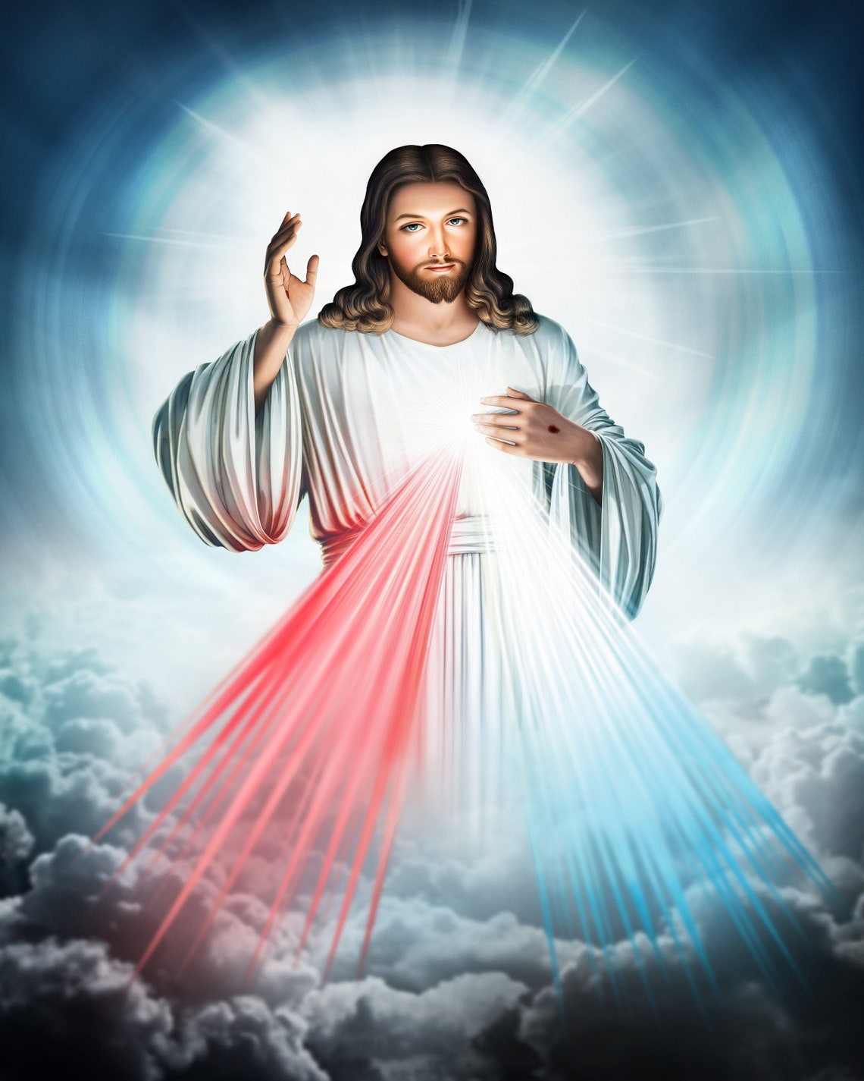

St. Brigid Family, Fun and Fellowship Festival

Saturday, June 20, 2026, from 3-9pm

Parishioners - This is your invitation to help make this year’s festival a community event and financial success.

WE NEED VOLUNTEERS TO HELP WITH ACTIVITIES/CHAIR BOOTHS

You can also donate NEW ITEMS OR HAND MADE CRAFTS OR DELICIOUS TREATS for the Silent Auction, Live Auction and prizes for booths.

If you have new ideas for the committee, PLEASE, share your ideas.

Capital Prize Raffle Tickets and Quilt Tickets will be available to purchase starting THIS WEEKEND.

Please call 270-877-2461 or 270-877-0546 and leave your name or family member’ names that would like to work at the festival.

Take a look at this beautiful quilt donated by Stella Ruley and her daughter, Phyllis Lynn.

