St. Brigid and St. John Catholic Church 2026
Sunday | Monday | Tuesday | Wednesday | Thursday | Friday | Saturday
 | 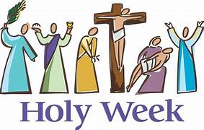 | March 31  Chrism Mass at Cathedral of the Assumption 10:30 a.m.  St. John 9:00 am Mass cancelled | 11:00 a.m. CCC 1    St. John 6:30 mass cancelled | 9:00 Mass cancelled 2  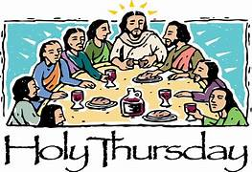  Mass times on Back | Office Closed 3    Mass times on Back | 4    8:30 p.m. Easter Vigil  St. Brigid
No RE Today 5  Mass times on back  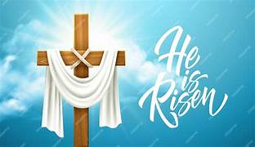 | 6  9:00 Mass Cancelled  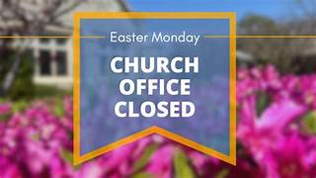 | 7 | 8 | 9    Noon and 6:30 p.m. | 10 | 11
Donut Sunday 12  after 9:00 Mass @ St. Brigid  St. John YM Scavenger Hunt  St. John First Communion Practice | 13  St. Vincent De Paul Meeting 5:30 St. Brigid Room/CCC | 14  Feeding America  5-7 p.m.  St. Brigid Finance Meeting 4:00 p.m. | 15 | 16 | 17 | 18
19    @ St. John 11:00 a.m.  Last class RE/St. Brigid | 20 | 21 | 22 | 23    St. John 6:00 p.m. | 24  Red Cross Blood Drive CCC 9/2  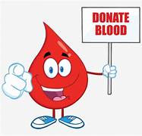 | 25
26  @ St. Brigid 9:00 a.m. | 27 | 28 | 29 | 30 |  | OVER
*See the bulletin for more information about these events * Follow the St. Brigid and St. John Church pages on Facebook * Visit the parish website at http://www.stbrigidvg.org
** If you have information you would like to add to the monthly calendar, please submit to the Parish office by the 20th of the prior month. brigidvg@bbtel.com
Per Archdiocese: Offices will be closed on Good Friday and Easter Monday


St. Brigid of Ireland: St. John the Baptist:
(Thursday, April 2nd -morning Mass cancelled ) (Wednesday, April 1 – 6:30 p.m. cancelled)
Holy Thursday, 5:00 p.m. Holy Thursday: 7:00 p.m.
Good Friday: 5:00 p.m. Good Friday, 7:00 p.m.
Holy Saturday Vigil 8:30 p.m. Holy Saturday: 6:30 p.m. Mass cancelled
Easter Sunday Mass: 9:00 a.m. Easter Sunday Mass: 7:00 a.m. and 11:00 a.m.
4:00 p.m. Mass Cancelled

