St. Brigid and St. John the Baptist Catholic Church 2025 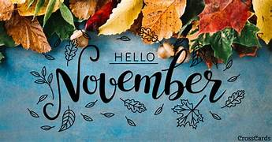
Sunday | Monday | Tuesday | Wednesday | Thursday | Friday | Saturday
Women’s Bible Study and Coffee -  Every Sunday, 9:30-10:45 St. John Rectory (during RE) |  |  |  |  |  | 1  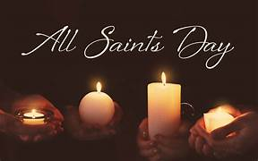
SCC After Mass 2  All Souls Mass @ 4:00 p.m.  Cemetery Blessings:  St.John-after 11:00 Mass  St. Brigid – 1:30 p.m.  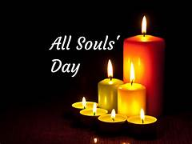 | 3  Bible Study, St. John 10:00 a.m. | 4  SCC 9:00- St. Brigid Room/ CCC  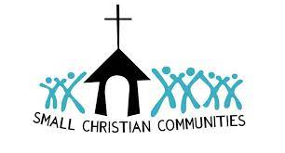 | 5  Young at Heart  Bring a side dish! 11:00 CCC | 6  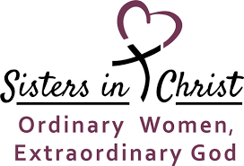  St. John – Noon & 6:30 | 7 | 8
SCC After Mass 9  Donuts After 9:00 mass    Angel Tree Shopping  St. John Youth 12-2 p.m.   | 10  Bible Study/St. John 10:00 a.m. | 11  SCC 9:00- St. Brigid Room/ CCC    Feeding America 5-7 | 12 | 13 | 14  St. Brigid/St. John Lock in – Grades 8-12 St. Brigid CCC | 15
SCC After Mass 16 | 17  Bible Study/St. John 10:00 a.m. | 18 | 19  First Reconciliation @ St. John 5:30 p.m.  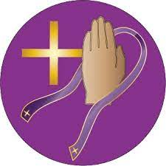  St. John Parish Council after 6:30 p.m. Mass | 20  St. Brigid Parish Council 7:00 p.m. | 21 | 22
SCC After Mass 23  Christ the King Sunday  30  First Sunday of Advent  HOPE | 24  Bible Study/St. John 10:00 a.m. | 25 | 26 | 27  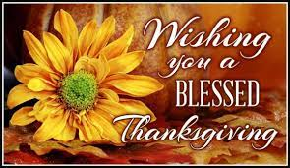 | 28  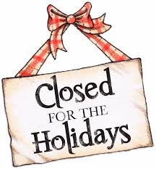 | 29
All Souls Day: Sunday, November 2: Cemetery Blessings - St. John after 11:00 a.m. Mass, St. Brigid 1:30 p.m.The 4:00 p.m. Mass at St. Brigid will be for All Souls Day. If you would like to bring a photo of your loved one for display, please drop off at the Church Office or bring Prior to Mass.
 Angel Tree Shopping – St. John Youth -November 9th 12-2pm St. Brigid and St. John Youth Group – grades 8-12th will be having a Lock IN at St. Brigid CCC (Gym) on Friday November 14. Watch bulletin or check with your Youth Leaders for more information.

November 23 – Our Lord Jesus Christ, King of the Universe - On the last Sunday of each liturgical year, the Church celebrates the Solemnity of Our Lord Jesus Christ, King of the Universe, or Christ the King. Pope Pius XI instituted this feast in 1925 with his encyclical Quas primas (“In the first”) to respond to growing secularism and atheism. He recognized that attempting to “thrust Jesus Christ and his holy law” out of public life would result in continuing discord among people and nations. This solemnity reminds us that while governments come and go, Christ reigns as King forever.
November 30th – The New Liturgical Year commences with the First Sunday of Advent and traditionally focuses on the theme of “Hope” . The first candle lit during Mass symbolizes the Hope we have in Christ and our desire to spend Eternity with him. We wait for Jesus with hope.
Room in the Inn News: Cold weather is upon us and preparations are being made to open the 24/7 Room In The Inn shelter. Now that we have a permanent building to house our guests we want to have an orientation for anyone wishing to volunteer. We want to make sure that all volunteers are keeping with the same rules and guidelines. Please prayerfully consider this wonderful ministry. Each year the demand for beds and food continue to grow. We desperately need overnight volunteers as well as daytime. If you cannot volunteer physically, food, financial and spiritual help is also needed. See bulletin for more information.

