St. Brigid and St. John the Baptist Catholic Church 2024 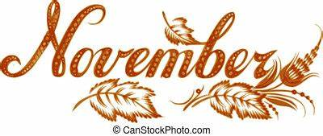
Sunday | Monday | Tuesday | Wednesday | Thursday | Friday | Saturday
 |  |  |  |  | 1  All Saints Day | 2  All Souls Day Mass  @ St. Brigid 10:00 am  Cemetery Blessing-St. Brigid 1:00 p.m.
SCC After Mass 3  Cemetery Blessing  St.John-after 11:00 Mass  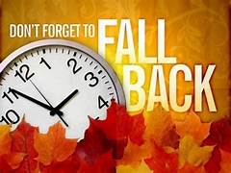 | 4  St. John Youth Service Day at St. James    Bible Study, St. John 10:00 a.m. | 5  SCC 9:00- St. Brigid Room/ CCC  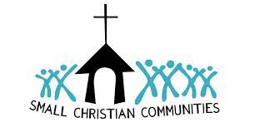 | 6  Young at Heart  Bring a side dish! 11:00 CCC | 7  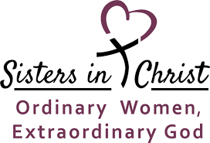  St. John – Noon & 6:30 | 8 | 9    Soup, sandwiches and BINGO! St. John  5:00 (See bulletin)
SCC After Mass 10  Donuts After 9:00 mass   | 11  Bible Study/St. John 10:00 a.m.   | 12  SCC 9:00- St. Brigid Room/ CCC | 13 | 14 | 15 | 16  St. John-Little Holy Land Tour  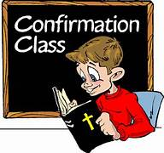
SCC After Mass 17  Father to meet with St. John First Reconciliation class after mass  First Reconciliation  @ St. Brigid 2:30 p.m.  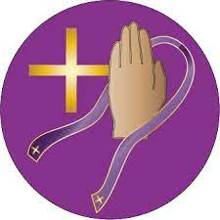 | 18  Bible Study/St. John 10:00 a.m. | 19  SCC 9:00- St. Brigid Room/ CCC | 20  First Reconciliation @ St. John 5:30 p.m.  St. John Parish Council after 6:30 p.m. Mass | 21  St. Brigid Parish Council 7:00 p.m. | 22 | 23
SCC After Mass 24  Christ the King Sunday  St. Brigid HS Youth - Parents Day Out -After RE - 11:30- 2p.m  CCC | 25  Bible Study/St. John 10:00 a.m. | 26  SCC 9:00- St. Brigid Room/ CCC | 27 | 28  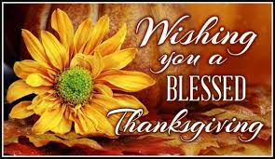 | 29  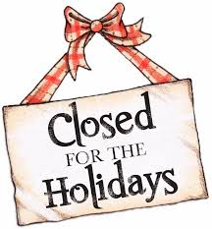 | 30

November 1 – All Saints Day : Holy Day of Obligation: All Saints' Day is a solemn holy day of the Catholic Church celebrated annually on November 1. The day is dedicated to the saints of the Church, that is, all those who have attained heaven. It should not be confused with All Souls' Day, which is observed on November 2, and is dedicated to those who have died and not yet reached heaven.

November 2 – All Souls Day: All Souls' Day, in Roman Catholicism, a day for commemoration of all the faithful departed, those baptized Christians who are believed to be in purgatory because they died with the guilt of lesser sins on their souls.
There will be an All Souls Day Mass at St. Brigid at 10:00 a.m. If you would like to bring a photo of your loved one for display, please drop off at the Church Office or bring Prior to Mass.
Cemetery Blessings: St. Brigid, 1:00 p.m. on November 2 and St. John after 11:00 a.m. Mass on November 3.

November 24 – Our Lord Jesus Christ, King of the Universe - On the last Sunday of each liturgical year, the Church celebrates the Solemnity of Our Lord Jesus Christ, King of the Universe, or Christ the King. Pope Pius XI instituted this feast in 1925 with his encyclical Quas primas (“In the first”) to respond to growing secularism and atheism. He recognized that attempting to “thrust Jesus Christ and his holy law” out of public life would result in continuing discord among people and nations. This solemnity reminds us that while governments come and go, Christ reigns as King forever.

